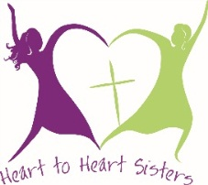

LWML New Jersey District Convention
Hyatt Regency, Morristown, NJ
August 17-19, 2018
Application for Heart-2-Heart Sister Representative Due by June 1, 2018

Prefix Miss Ms Mrs Other (please specify}
Country of Origin

Last Name
First Name
Middle Initial

Address

City
State
Zip Code

Primary Phone Alternate Phone

E-mail Address

Home Church Name
Pastor’s Name
Home Church Address

Home Church City
State
Zip Code

Describe your ministry involvement

About which area of ministry are you most passionate?

Share a little about your family

Education

Work Experience

When and how did you become a Lutheran Christian?
___________________________________________________________________________________________________________

Heart to Heart Sister Candidates will be ethnic women who speak various languages. Do you consider yourself to be fluent in English, or would you require a translator to accompany you?

Yes, I am fluent in English. No, I understand some English, but would require help from a translator.

We request that applicants participate in the entire LWML Convention.
Are you able to do this? Yes No

Please submit this form by mail to District Board by June 1, 2018.
Mail applications to Arlene Price, 13 Mariner Drive, Randolph, NJ 07869 or email to arlene.lwml@optimum.net

