GOLFERS REGISTRATION

My Name: _______________________________ Address: _______________________________
City/State/Zip:

Phone: Email: _______________________________

Player 2 Name:
Address: _______________________________
City/State/Zip:

Phone: Email: _______________________________

Player 3 Name: _______________________________
Address: _______________________________
City/State/Zip: _______________________________
Phone: _______________________________
Email: _______________________________

Player 4 Name: _______________________________
Address: _______________________________
City/State/Zip: _______________________________
Phone: _______________________________
Email: ________________________________

REGISTER ON-LINE AT

WWW.NJDISTRICT.ORG/MCGOLF
EVENT SCHEDULE
Registration…………………………...…..…. 7:30 am Driving Range & Putting Green……...…....… 7:30 am Shotgun Start ………………………...….……8:45 am Awards Luncheon………………...…....….… 1:30 pm

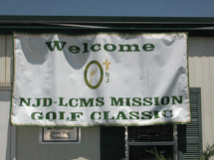
EVENT FORMAT
Four Person Team Scramble 1st, 2nd, & 3rd Place Team Awards

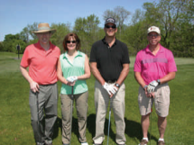

CONTESTS
Hole-In-One Prize Closest to the Pin (2)
Men’s and Ladies’ Longest Drives

HOW WELL WE’VE DONE
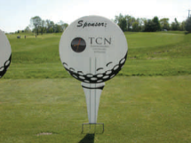
Since the Mission Classic began, we have raised nearly $250,000
in support of the NJ District missions.
…Let’s make this our best support
year yet!

DIRECTIONS TO HERON GLEN GOLF COURSE
From NJ Turnpike, GSP South, and Rt. 287 South: Take 287 North to Rt. 22 West. Travel on Rt. 22 to Rt. 202 South.
and
Stay on Rt. 202 as it goes over the Somerville Circle and around the Flemington Circle. Once you pass Copper Hill Rd., take the next jug handle to get onto Rt. 202 North. Make right at Gulf Station to Heron Glen.
From Route 287 North: Take Rt. 287 South to Exit 17 for Rt. 202 South and follow directions above.
From Trenton Area: Take Rt. 31 North to Rt. 202/31 North. Make right at Gulf Station to Heron Glen.
WE APPRECIATE YOUR SUPPORT!

L C M S NEW JERSEY DISTRICT

Mission Classic
Golf Outing

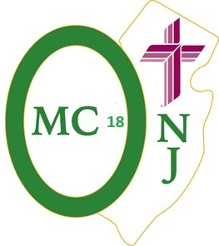
THURSDAY, MAY 2, 2024
To Benefit:
Hispanic Ministry

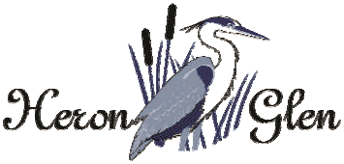

110 Hwy 202 & 31
Ringoes, New Jersey 08551

For Information Call: 908-953-9852

I would like to make the following donation
☐$50 ☐ $100 ☐ $250 ☐ other_________________
GOLFER PARTICIPATION NON-GOLFER PARTICIPATION
REPLY CARD

□ .……$10,000

Foursome & Tee Sponsor………………$ 880
Includes golf for four (4), tee sponsorship.

2 Players & Tee Sponsor….. ……….….$490
Includes 2-golfers and name/logo on tee sign
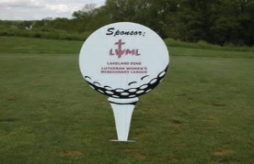

Carts Sponsor………………...…...…..….....$1,500
Includes name and logo on all of the golf carts Limited to two (2) sponsors only.

Awards Luncheon Sponsor.....…… ….…...$1,000
Includes name on sponsor board prominently displayed at registration and lunch

Player Gifts Sponsor…………...…….…...$750
Includes name on sponsor board prominently displayed at registration and lunch
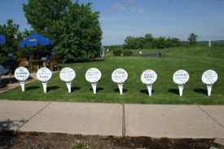

- Foursome & Tee Sponsor ……….……….......….$880
Tear Here Before Mailing
- Carts Sponsor…………..…………………... ..$1,500
- Awards Luncheon Sponsor………...…..…........$1,000
- Player Gifts Sponsor ……………...….…..……..$750

- Hole in One Sponsor……………………….……..$500
- Tee Sponsor………………………..……......…...$150
- 2-Players & Tee Sponsor.…...……...........………$490
- Player & Tee Sponsor.….……….…..……..… …$295
- Player………………………………….…...…….$195
Tear Here Before Mailing

I would like my sponsor sign to read as follows:
Or email High Res LOGO (JPG, TIFF, or PDF) to address below

____________________________
Name: __________________________________
Congregation: ____________________________
Home Address: ___________________________
City: ____________________________________
State/Zip: ________________________________
Phone: __________________________________
Email: __________________________________

1 Player & Tee Sponsor…………….....….$295
Includes 1-golfer and name/logo on tee sign and in event program.

- Player……………………………………..$195

Tear Here Before Mailing

Hole in One Sponsor …………...…….…….$500

Tee Sponsor …………...…….…….$150

Credit Card Payment & Registration:
www.njdistrict.org/mcgolf
Make check payable to: LCMS–NJ District

Send Check & Reply Card to: Mission Classic
NJ District LC-MS
1168 Springfield Ave.
Mountainside, NJ 07092
FOR INFORMATION CALL:
TEL: 908-233-8111
EMAIL: MISSIONCLASSIC@NJDISTRICT.org

