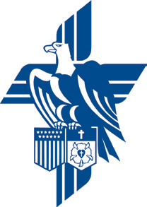

The Operation Barnabas Chapter of
Zion Evangelical Lutheran Church
Presents a Program of
Information and Guidance on
Veteran's Benefits available from the U.S. Veterans Administration

Please join us on Wednesday, May 25, 2016 at 7:00 pm when the Operation Barnabas Chapter of Zion Evangelical Lutheran Church, Westwood, NJ hosts Mr. Frank Quadrino, Manager of Outreach Programs for the Veterans Administration, U.S. Department of Veterans Affairs.

Mr. Frank Quadrino will be speaking on benefits available to all Veterans and special programs available for Women Veterans. The topics include:

- Who - is entitled to benefits.
- What - are the benefits.
- When - can you receive benefits.
- Where - do I sign up for benefits.
- How - can I apply for benefits.

Following the presentation, please stay for light refreshments and fellowship. You are also invited to come early to join us for a Special Service of Welcome and Thanks to Veterans that will be held in the Church Sanctuary at 6:30 PM. Zion Evangelical Lutheran Church – Westwood, NJ. 155 Second Avenue, Westwood, NJ 07675.

You need not register in advance, but we would appreciated if you could let us know you are coming using this Evite link. http://evite.me/Rj5ceSFrVU.

Questions: Please contact Bill Schmidt at operationbarnabas@njdistrict.org or 201-314-9875.

